ETHICAL SHORT-TERM MISSIONS & VOLUNTEERING

Selecting an ETHICAL TRIP
FOR INDIVIDUALS
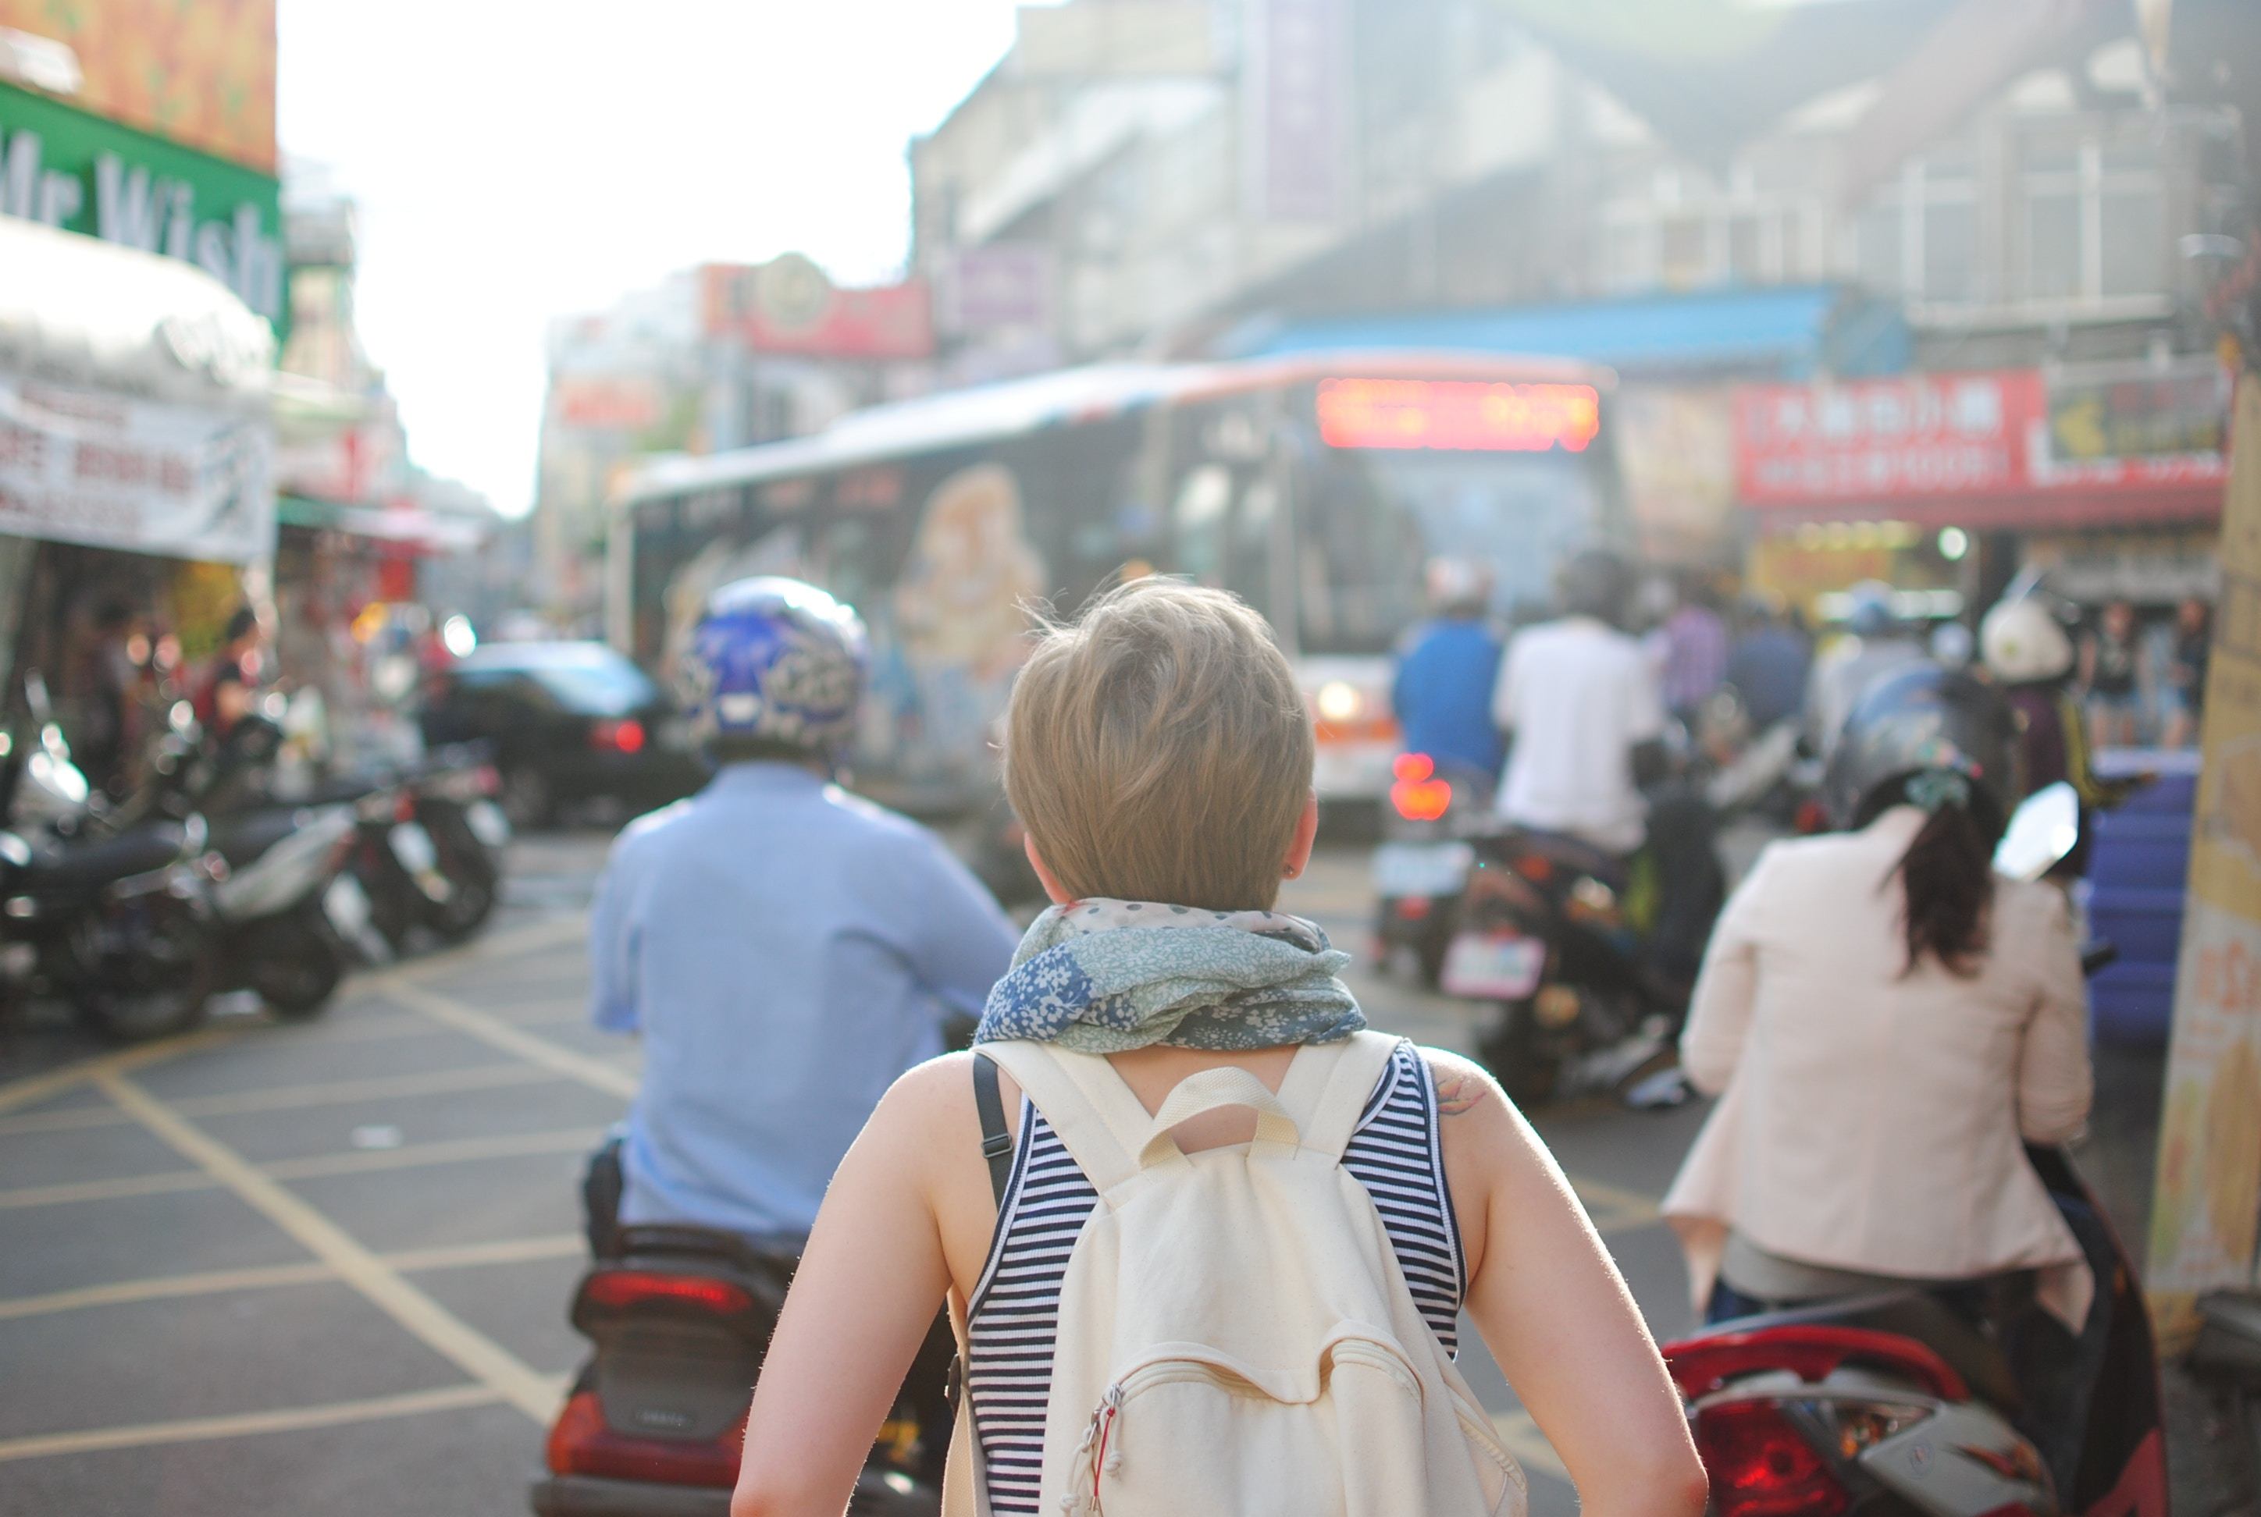

ethicalmissionstrips.org

SeLecting an ETHICAL STM or Volunteer TRIP
Tip: There are multiple ways to gather information about an organisation or STM program including by:
- conducting web searches;
- contacting the organisation/s; and
- speaking to returned volunteers.
The key to selecting an ethical trip is asking the right questions, gathering accurate information, and evaluating the organisation and the opportunity on the basis of the ethical considerations.

The following tool has been designed to help you with this evaluation.

ASESS THE ORGANISATIONS:

STEP 1: VISION & MISSION STATEMENT |  | YES | NO | UNSURE
 | Does the organisation have a clear vision & mission statement? |  |  |  | Vision and mission statements play an important role in goal setting and ensuring organisations have a clear focus and purpose. Without them organisations are more likely to program based on trends or the interests of donors or volunteers instead of what’s best for the local community.  The language used by organisations can give us insight into their approach. For example, organisations who recognise community assets and see their role as supporting community initiative are more likely to utilise volunteers in ways that build local capacity and avoid activities that disempower local people.
Does the vision & mission statement emphasise:
- the strengths of local communities and the supporting role played by the organisation (and volunteers) to enhance community strengths?
i.e. ‘supporting the rights of people’, ‘building the capacity of…‘, ‘promoting the rights of…
OR
- the helplessness of local people and their needs and deficits and the ‘saviour’ role played by the organisation (and volunteers)?
i.e. ‘, ‘feeding the hungry’ ‘rescuing the vulnerable’

STEP 2: ASSESS THE ORGANISATIONS WEBSITE, SOCIAL MEDIA & OTHER COMMUNICATIONS |  | YES | NO | UNSURE
 | Does the organisation’s website, social media and other communications materials:  - portray local communities and children in a positive and affirming way?  i.e. children & adults are not presented as helpless, in distress or dishevelled. People are portrayed as being active in their own change process and not entirely dependent on volunteers or organisations. |  |  |  | Good organisations prioritise the dignity of children and communities over the emotional pull of an image or story.  When organisations lack boundaries in their communications they are less likely to uphold healthy boundaries in their programs, including their use of volunteers and STM teams. .  For ethical STM its important to source organisations who are conscious of protecting their beneficiaries and putting the needs and interests of local communities above what is attractive to potential donors or teams.
- provide balanced, realistic and factual information and avoid embellishing the organisation’s role or exaggerating issues?
i.e. is not emotionally manipulative, does not use sweeping generalisations or overemphasising the victim and role of organisation and volunteers as savours
- protect the rights and safety of children and other vulnerable groups?
i.e. children are adequately clothed, no identifying photos or information is provided when discussing issues that carry a risk of stigma or risk to safety.

STEP 3: EVALUATE THE ORGANISATION’S CHILD PROTECTION POLICY & PROCEDURES |  | YES | NO | UNSURE
 | Does the organisation have a child protection policy? |  |  |  | Failing to be clear about what is and isn’t appropriate interaction with children places children at risk.  It also makes an organisation more vulnerable to being targeted by someone seeking easy unregulated access to children in order to exploit them.
If yes, does it provide guidelines around:
- appropriate/inappropriate behaviours (code of conduct)?
- Taking and using photos and information (e.g. social media)?
- reporting child protection allegations or incidents?

STEP 4: ASSESS STM APPROACH AND PROCEDURES |  | YES | NO | UNSURE
 | Does the organisation:  - Recruit volunteers and team members who have the specific skills required by the project  or  Find out what skills volunteers/team members have and, consider how they can be used to serve the goals of local communities/projects and offer the team roles accordingly.  or  Develop a trip itinerary to meet the stated goals and desires of the team |  |  |  | How an organisation recruits team members can reveal how they prioritise the needs of local communities and organisations over the needs and requests of team members.
 | Does the organisation have adequate screening processes for all STM team members and volunteers, which includes:  - interviews, background checks, reference checks, working with children checks (when applicable) and assessment of skills and qualifications. |  |  |  | Good organisations have proper screening processes in place to ensure the right team members are selected who will act ethically, are child safe and who meet the requirement’ s of the type of trip selected.  Screening should be a standard practice for everyone who applies, without exception. It can be tempting to choose not to screen people when they are known through church or other connections. But making case-by-case decisions about who should and shouldn’t be screened introduces an unnecessary ‘grey area’ and exposes everyone involved to unnecessary risk.
 | Is it made clear how any volunteer fees will be used and do local communities benefit appropriately from these fees?  i.e. are they transparent about the breakdown of fees and profit margins. |  |  |  | Volunteer fees should not only be used to cover costs or profit facilitating organisations. An appropriate portion of funds should also go towards supporting the initiatives and programs in the communities teams engage with.  Organisations that organise trips for the purpose of generating profit at the expense of what is in the best interest of children and communities should be avoided.
 | Does the organisation outline clear and appropriate boundaries for teams and volunteers?  i.e. around contact with local people, contact with children, cultural considerations, the use of social media. |  |  |  | In cross cultural settings, everything can feel foreign and it can be easy to become unsure of what constitutes appropriate behaviour. This is why it is so important that organisations provide clear guidelines and boundaries before the trip to avoid team members acting inappropriately and causing unintentional harm.

STEP 5: IDENTIFY ANY HIGH-RISK AREAS |  | YES | NO | UNSURE
 | Does the organisation facilitate teams to volunteer in activities that carry a well-known and documented risk of harm such as: |  |  |  | Remember good intentions don’t automatically result in good outcomes and therefore when volunteers engage in activities that are know to cause harm, either on an individual a systems level, alternatives needs to be sought.
 | - Visiting or volunteering with children in residential care.  i.e. This includes orphanages, children’s homes, children’s villages, shelters, rescue homes, etc. |  |  |  | Volunteering and visiting children in residential care (e.g. orphanages) is one of these areas. For info unpacking the harmful effect of orphanage volunteering- ethicalmissionstrips.org/orphanagevolunteering/
 | - Participating in 'raids and rescues' for children or adults.  i.e. ‘rescuing’ of trafficked victims, child protection interventions, removing children from situations of abuse or placing children in residential care. |  |  |  | Teams should never get involved in legal and criminal matters or child protection interventions. This must be left to the relevant authorities and licensed organisations.  Teams should report all child protection concerns to the authorities or an in-country NGO who specializes in child protection.
 | - Engaging in humanitarian/disaster relief work or sending teams into conflict zones. |  |  |  | Post disaster or humanitarian crisis situations are very complex and dangerous, and generally not suitable for unqualified STM teams.  There many examples, of well-intentioned teams volunteering in the aftermath of a disaster and causing more harm than good by duplicating services, taking over local led responses, bringing unusable goods into the country, using scarce resources, and responding inappropriately to the needs of orphaned and unaccompanied children. Non-specialised teams should consider waiting and supporting the long-term rebuilding efforts after the initial response has passed.  Volunteering in post disaster/emergency context should be reserved for specialised volunteers being deployed by disaster response agencies.
 | - Providing medical care |  |  |  | Medical STM is a high-risk area.  Even for qualified doctors, there are risks to providing medical or dental treatment to people overseas without knowledge of patient’s medical histories.  Consideration should be given to sustainability, particularly in the case of pop up medical clinics.  Surgeons and specialists should volunteer through formal hospital skills exchange and volunteer programs to maximize impact and ensure proper after care and follow up arrangements are in place.  Doctors may need to apply for local licenses or special government permission to practice in a foreign country, so make sure you look into this well in advance and acquire all appropriate licenses.  There have been prosecutions against volunteer doctors on STM trips practicing without license and in cases where death or disability has ensued.

STEP 6: REFLECT ON THE TRIP ITINERARY |  | Yes | No | Unsure
 | - With my current skills and qualifications, would I be permitted to undertake the same role (being proposed on the trip) in my own context?  - If YES, is it appropriate given my level of local language skills, cultural knowledge, understanding of local systems, laws etc.? |  |  |  | It is never wise for teams to take on tasks which they are unqualified for and lack experience to do. This can lead to wasted resource, duplication, poor outcomes, accidents and hazards. When working with children, it can lead to harm and can undermine children’s development. Parents and community members are likely to assume teams are qualified, therefore we need to be very responsible with their trust.
 |  |  |  |  | It’s also important to realise that whilst team members might be trained and have experience, the context may be very different and the cultural and language barriers will make it challenging for them to transfer their skills. It is wise to think through how you will overcome context related challenges.
 | Would I be happy if a team (with the same level of skills and qualification) did the same proposed activities in my community, school, church, workplace or with my children? |  |  |  | For example, would I be comfortable with my child (or a child I cared about):  - receiving medical treatment from a team of foreign doctors who have no knowledge of my child’s medical history?  - attending a school or day care that relies on untrained short-term volunteers from non-English speaking countries?  Even if the service is genuinely required, we need to consider alternative ways that don’t compromises the rights and long-term care of children or community’ members. For example, rather than providing direct treatment, medical teams could help build the capacity of local clinics so adults and children can access better medical care long-term.
 | Is the sector I am considering volunteering in:  - a sector I and other team members have experience in?  - a sector where I and other team members are familiar with the sector specific good practice and guiding principles? |  |  |  | Sectors include education, healthcare, law, child protection, business, church planting/ministry, mental health, welfare etc.  Most sectors have good practice principles or codes of ethics in place that set the standards for professional practice and conduct as well as prevent harm.
 | Is the organisation asking volunteers to do things that the community could most likely do for themselves? |  |  |  | Doing something for a community that they are already capable of doing themselves can be disempowering. It can subtly reinforce inferiority and discourage community-led action. Consider doing something ‘with’ rather than ‘for’ the community. Where possible encourage local initiatives and where extra hands and manpower is helpful, work alongside the community. This fosters relationship and communicates that you respect, recognise and value the skills local people already possess.
 | With respect to the goals and activities of this trip, who has the long-term responsibility (duty bearer)? | Duty bearer: |  |  | For every human right, there is someone responsible for making sure people can achieve that right. These people are called duty bearers. A person is a duty bearer on the basis of their role/occupation, i.e. parents for children’s care, teachers for student’s education. The best way for teams to support people to access their rights is by supporting duty bearers to fulfil their roles. When teams take over the roles of duty bearers it can be detrimental in the long-term. They can cause disruption, inconsistency, and undermine the social systems that children and communities depend on.  For more info see: ethicalmissionstrips.org/principles/
Does the organisation intend to utilise team members to:
- build the capacity of the duty bearer so they can better fulfil their responsibility?
or
- participate in an activity which will temporary replace them from their role?

ASSESSING THE CHECKLIST

Go back over your responses in the checklist and use the key below to assess your answers. Reflect on any areas where you’ve identified concerns or gaps in information.

- SAFE: Based on your answers there are no concerns.

- APPROACH WITH CAUTION: Carefully consider any areas where caution is advised and ask more questions of the facilitating organisation if necessary. See if there are simple adjustments that could be made to reduce any risks or enhance outcomes for local communities. Refer back to the website or linked resources to assist you.

- WARNING: If you ticked any red boxes, then it is strongly advised that you reconsider taking part in the trip or any high-risk activities, due to the well documented risk of harm that could be caused to children or communities.

- UNSURE: Conduct any further research or thinking so you can answer questions marked as unsure before continuing with your planned involvement in STM.

DRAWING CONCLUSIONS

SHOULD I JOIN THIS TRIP? | Next step:
Yes – Based on my research and assessment of the organisation and taking into consideration my own skills and experience, I am confident this is an ethical STM trip. | Apply to join the STM trip.
 Maybe - I need to gather more information and clarify any areas that I am unsure about or have potential concern before deciding whether I should join this trip. | Continue research.
 No – Things have been raised during the assessment about the organisation, the trip, my suitability or other factors that have convinced me that I should look for another alternative. | Explore and assess alternative trips.

